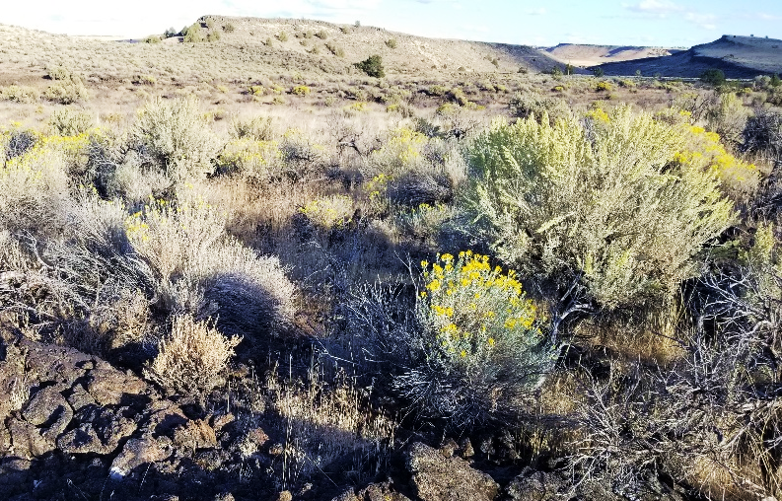
Rangeland Science Aide

Job Title: Biological Science Aide
Series/Grade: GS-0404-03/04
Desired Start Date: April/May 2019
Position Length: 4-6 months
Location: Eastern Oregon Agricultural Research Center (EOARC), Burns, OR

Job Duties: Provide assistance to ecologists with lab and fieldwork in sagebrush steppe plant communities in the Northern Great Basin. Projects will be focused on the ecology of seeds and seedlings for restoration projects where rangelands are degraded by fire or invasive species. Knowledge of common rangeland plants, soils, ecosites, etc. would be an asset. Common tasks may include the following: following protocols for surveying and sampling vegetation and soil, processing soil samples in the lab, sorting and counting seeds/seedlings at a species level, dissection of plant material, plant taxonomy, examining the soil surface for cryptic species, and quantifying microsite characteristics of the plant-soil interface.

Requirements: Undergraduate or recent graduate in range, botany, or other natural resource fields. Must be able to work in all field conditions (all seasons and weather) where periods of kneeling/squatting are expected for data/sample collection, and hiking on variable terrain Is expected. This work will occur in a high desert environment, which has hot-dry summers. Travel to remote locations with overnight stay in camps or field housing is also possible, thus a valid driver’s license is necessary. Enthusiasm for fieldwork, the ability to perform tedious, repetitive tasks, and an eye for detail is required. Previous experience would be considered an asset. Relevant education or experience will be considered. Must be a United States citizen.

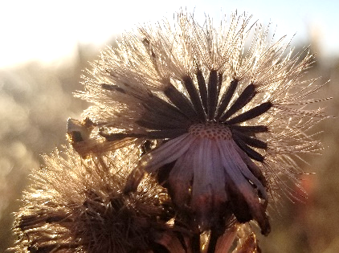
GS-3: Successful completion of 1 year of study that included at least 6 semester hours in any combination of scientific or technical courses such as biology, chemistry, statistics, entomology, animal husbandry, botany, physics, agriculture, or mathematics OR 6 months of general experience, which demonstrates the ability to perform the work of the position.

GS-4: 6 months of general and 6 months of specialized experience OR successful completion of 2 years of post high school study that included at least 12 semester hours in any combination of courses such as biology, chemistry, statistics, entomology, animal husbandry, botany, physics, agriculture or mathematics of which 6 semester hours of courses relate directly to the duties of the position (plant biology, range/ecology, or natural resource management). General experience must have demonstrated the ability to perform the work of the position or provided a familiarity with the subject matter. Specialized experience must have been at least equivalent to the GS-03 grade level in the Federal Service.

Wage and Housing: $12.74 to $14.30 /hr depending on experience and education. Work weeks are typically 40 hours, longer hours are typical during fieldwork. Housing and utilities are provided at the research station in Burns.

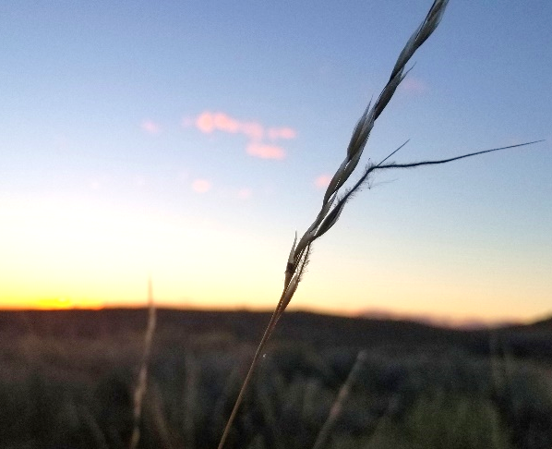
To Apply: Contact lapyle@ucanr.edu with a cover letter, resume, and transcripts (unofficial are permitted). List any classes you have taken in range science, botany, wildlife, soils, and environmental science. In your cover letter emphasize experience relevant to aspects fieldwork/lab work or the potential tasks described above. Applications will be considered as they are received.

USDA-ARS is an Affirmative Action/Equal Opportunity Employer.

Lysandra Pyle
University of California, Davis – Agriculture and Natural Resources
Eastern Oregon Agricultural Research Center
67826-A Hwy 205
Burns, OR 97720
lapyle@ucanr.edu

