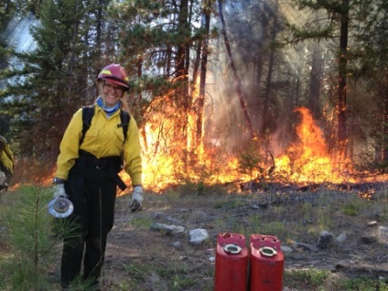
Colville National Forest
Outreach for Soil Crew Positions
GS-0404-5 – Biological Science Technician (Soils) – 3 positions
GS-0404-6 – Biological Science Technician (Soils) – 1 position

Application period – Nov 5th, 2021 to November 12th, 2021
Apply through usajobs.gov - up to 4 positions hired
Employment would be from May 2022 to November 2022

The Colville National Forest’s Soil Crew has four open positions for seasonal soil technicians. We work 10-hour days, Monday through Thursday. After training and orientation, we survey potential timber units in our large-scale restoration projects using the National Forest Soil Disturbance Monitoring Protocol. Another important component of our restoration project work is wetland survey, in which we examine soils, hydrology, and vegetation to determine the function of mapped wetlands. Work involves carrying a heavy shovel around the woods and crashing through brush up and down steep and rough terrain. Data collected in the field is used to write our soil NEPA documents and to inform our treatment prescriptions. The work involves long days walking in rough conditions collecting data using ESRI field applications. We will experience rain, biting insects, hot weather, smoke, more rain, snow, and ice in the field.

Secondary projects/activities include precipitation gauge monitoring, post-harvest soil disturbance monitoring, and support of other natural resource crews. The Soil Crew also organizes, enters, and manages all field data collected during the season. We use Microsoft Office, ArcGIS, and other computer programs throughout the season to analyze and process our data. There will also be opportunities to write monitoring reports, assist with technical documents, and engage with the public. For interested people who can pass the arduous pack test and complete guard school, or folks with current red card qualifications, there are opportunities to work locally responding to wildland fires. Crew members may also support wildfire incidents as a Resource Advisor or Burned Area Emergency Response (BAER) specialist. Finally, we spend time with chainsaw qualifications and skills in support of soils and other resource projects.

The Colville National Forest is located two hours north of Spokane in the northeast corner of Washington State. The Forest is 1.5 million acres with very active timber and fire programs. It is a place with moose, grizzly bears, and wolves and a diverse range of vegetation from dry ponderosa pine to cold and wet cedar stands. Opportunities for hunting and fishing abound. The Colville National Forest is a beautiful place to live and work. Kettle Falls, despite only having a population of 1,600 people, has a natural food store (Meyers Falls Market), a brewery (Northern Ales), and several restaurant choices. The town of Colville is 10 miles away and is the county seat having larger stores and services as well as a twice a week farmer’s markets, a drive-in movie theater, and other activities. Recreation and cultural activities just north into British Columbia, Canada abound, amazing backpacking, hiking, mountain biking, hot springs, and more.

We do not currently have a USAjobs announcement number. Please look for the position using search terms “Soil” or “Kettle Falls, WA” as a duty station. Any issues during the application process please contact us; applying for Forest Service jobs can be challenging and we want folks to be successful. For additional questions or concerns, contact Jason Jimenez (jason.jimenez@usda.gov), or Kyle Johnson (kyle.johnson2@usda.gov)
