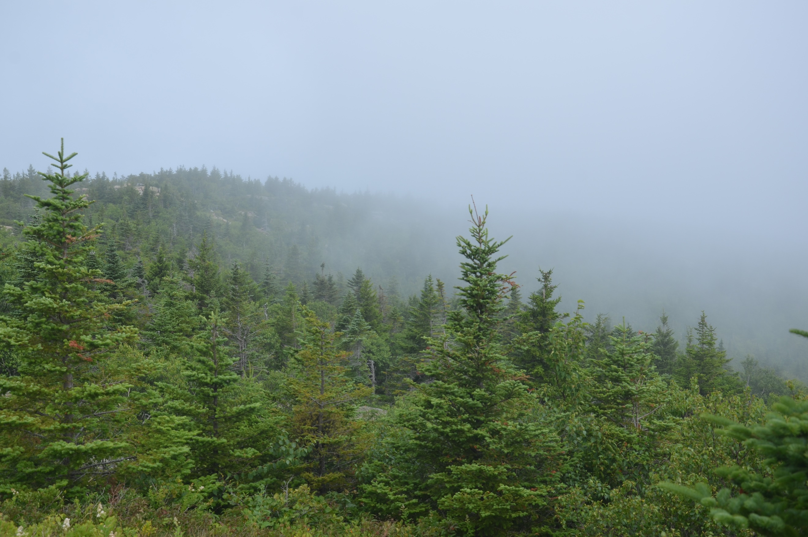

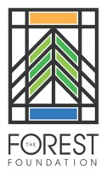 | David A. Bischel Forestry Scholarship | 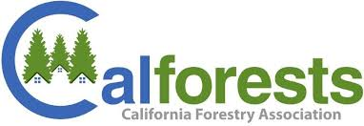

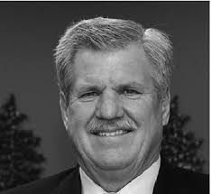
This scholarship honors the memory of David Bischel. Dave was a graduate of both UC Berkeley and UC Davis. He was a Registered Professional Forester who started his career as a field forester and always maintained a passion for work in the woods. Later in his career, Dave would serve his profession as the Executive Officer for the Foresters Licensing Program and as the Executive Officer of the California Board of Forestry and Fire Protection. Dave became the President and CEO of the California Forestry Association in 1995 – a role he would hold for twenty-two years. During his career Dave was a staunch advocate for active forest management and promoted sound forest practices. Dave retired from Calforests in 2017 and on April 25, 2019 Dave passed away after losing a battle to cancer. To honor Dave Bischel’s contributions and commitment to the forestry sector, The Forest Foundation and the California Forestry Association are collaborating to provide the David A. Bischel Scholarship Program in his memory. This scholarship will be awarded to students who embody Dave’s zest for forestry and active management to promote sound forest principles.

Eligibility

Students who are entering their junior year, are seniors or are graduate students in a program leading to a career in forestry at UC Berkeley, Cal Poly San Luis Obispo, or Cal Poly Humboldt are eligible to apply.

Description of Scholarship

One or more awards of at least $2,500 each will be made for the academic year beginning in the
fall of 2022. Scholarship funds may be used for tuition, books, or enrollment in a related degree and accredited summer learning program.

Applications

Send an email to contact@calforestfoundation.org for application information. Applications are due on Monday, April 18, 2022.

